NAME: VENKATRAMAMOORTHY.G
Task 1:
Build a responsive navbar with a collapsible toggle for mobile.
CODE:
<nav class="navbar navbar-expand-lg navbar-dark bg-dark">
<div class="container">
<h1 class="navbar-brand">MyWebsite</h1>
<button class="navbar-toggler" type="button" data-bs-toggle="collapse" data-bs-target="#navbarNav">
<span class="navbar-toggler-icon"></span>
</button>
<div class="collapse navbar-collapse" id="navbarNav">
<ul class="navbar-nav ms-auto">
<li class="nav-item">
<a class="nav-link active" href="#">Home</a>
</li>
<li class="nav-item">
<a class="nav-link" href="#">About</a>
</li>
<li class="nav-item dropdown">
<a class="nav-link dropdown-toggle" href="#" role="button" data-bs-toggle="dropdown">
Services
</a>
<ul class="dropdown-menu">
<li><a class="dropdown-item" href="#">Web Development</a></li>
<li><a class="dropdown-item" href="#">App Development</a></li>
<li><a class="dropdown-item" href="#">SEO</a></li>
</ul>
</li>
</ul>
</div>
</div>
</nav>
OUTPUT:
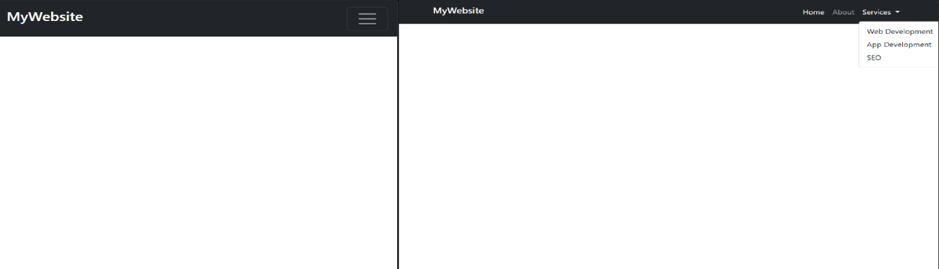
Task 2:
Create a few buttons with different styles (.btn-primary, .btn-outline-success, etc.).
Add an alert box with a dismiss button.
CODE:
<button class="btn btn-primary m-3" data-bs-toggle="modal" data-bs-target="#mod1">Open dialog</button>
<button class="btn btn-outline-success m-3" data-bs-toggle="modal" data-bs-target="#mod1">Open dialog</button>
<div class="modal" id="mod1">
<div class="modal-dialog">
<div class="modal-content">
<div class="modal-header">
<h1>Alert</h1>
</div>
<div class="modal-body">
<p>Do you want to delete</p>
</div>
<div class="modal-footer">
<button class="btn btn-danger">Delete</button>
<button class="btn btn-secondary" data-bs-dismiss="modal">close</button>
</div></div></div></div>

OUTPUT:
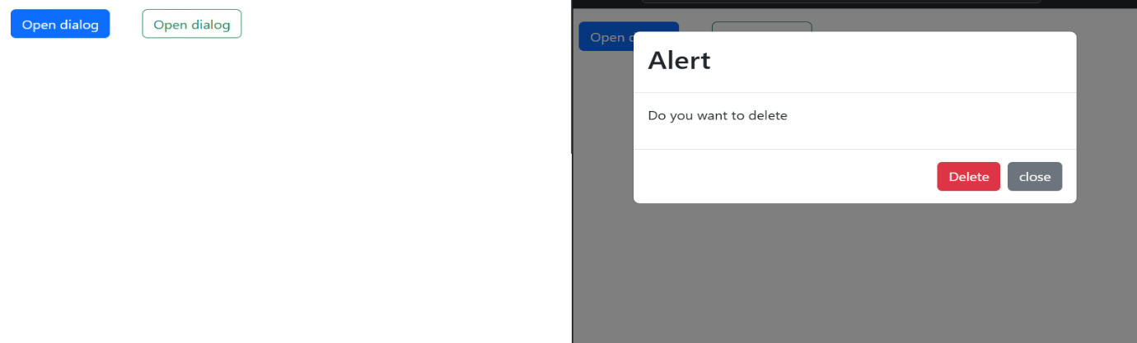
Task 3:
Create a contact form with name, email, and message fields.
Use .form-control and .form-label.
CODE:
<div class="d-flex justify-content-center align-items-center vh-100">
<div class="card p-4 shadow" style="width: 300px;">
<h4 class="text-center mb-3">Login</h4>
<div class="mb-3">
<label class="form-label">Email</label>
<input class="form-control" type="email" placeholder="Enter email">
</div>
<div class="mb-3">
<label class="form-label">Password</label>
<input class="form-control" type="password" placeholder="Enter password">
</div>
<div class="d-flex justify-content-between mb-3">
<button class="btn btn-primary w-50 me-2">Login</button>
<button class="btn btn-danger w-50">Cancel</button>
</div>
<div class="form-check">
<input class="form-check-input" type="checkbox">
<label class="form-check-label">Remember me</label></div></div> </div>
OUTPUT:
